Step1-> create react project and add Dockerfile in root folder.

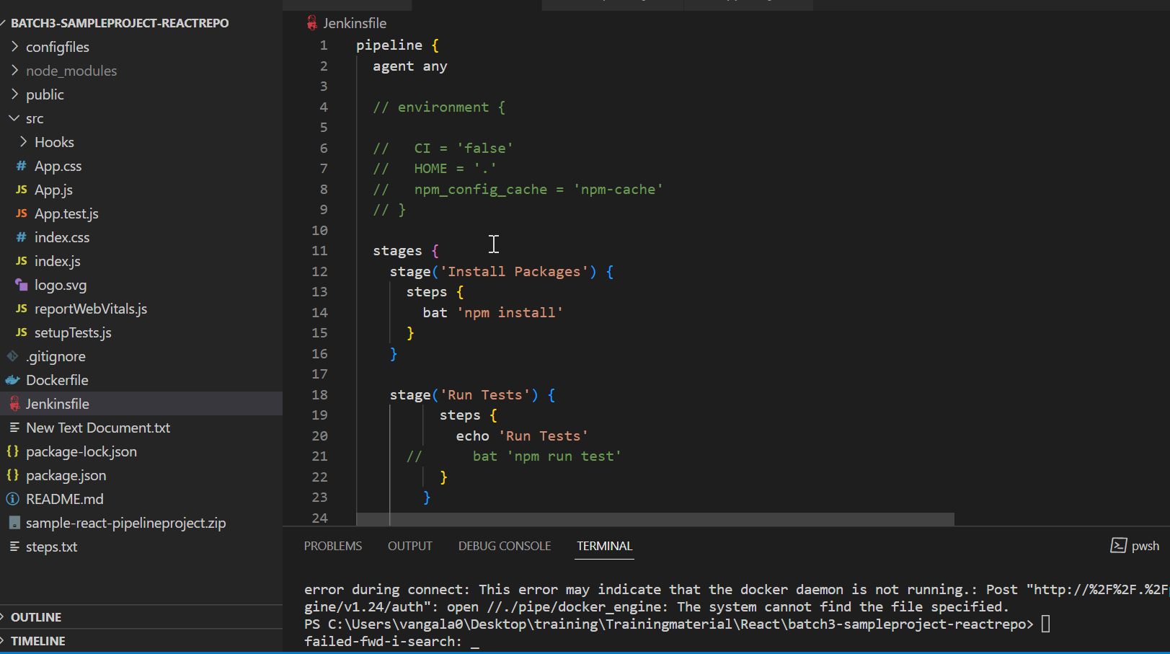

Step2-> Write following configuration into Dockerfile

FROM docker.repository.esi.adp.com/clientcentral/node:12.7.0

WORKDIR /app

COPY package.json .

#RUN npm i

#RUN npm install

COPY . .

CMD ["npm", "start"]

EXPOSE 3000

Need to pull node image from repository, specifying folder name where project locate din container ,copy package.json file , command to run project , specify port number where project is exposed.

If you run num install in VM/host this step is not needed so it is comment

Step 3->create CI/CD pipeline

pipeline {

  agent any

  stages {

    stage('Install Packages') {

      steps {

        bat 'npm install'

      }

    }

    stage('Run Tests') {

          steps {

            echo 'Run Tests'

          }

        }

    stage('SonarQube Coverage') {

          steps {

            echo 'SonarQube Coverage'

            bat 'npm run test:report'

             bat '''sonar-scanner

             -Dsonar.host.url=http://CDLVDIDEVMAN500:9000

             -Dsonar.login=924f27e70c7d1145f7cee87dc5a67e340ab2d0a9'''

             }

      }

      stage('Create Build Artifacts') {

          steps {

            bat 'npm run build'

          }

        }

      stage('Docker Build') {

            steps {

            echo 'Docker Build'

        bat 'docker build -t   docker.repository.esi.adp.com/clientcentral/training:batch3-sample-ui -f Dockerfile .'

    }

        }

    stage('Docker Push'){

            steps {

                bat 'docker push docker.repository.esi.adp.com/clientcentral/training:batch3-sample-ui'

            }

        }

        stage('Docker deploy'){

            steps {

                bat 'docker run -itd -p  3000:3000 docker.repository.esi.adp.com/clientcentral/training:batch3-sample-ui'

            }

        }

  }

    stage('Remove Unused docker image') {

      steps{

        bat "docker rmi docker.repository.esi.adp.com/clientcentral/training: batch3-sample-ui'"

      }

    }

}